Symbols
by car

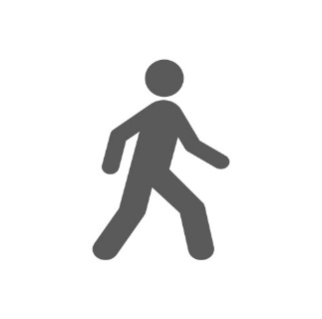

walking distance

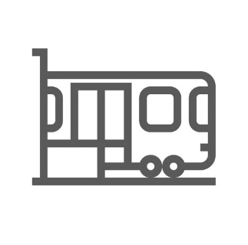

by train

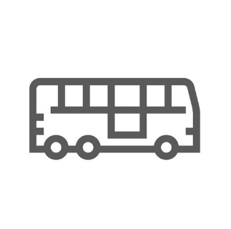

by bus

Hotels – Travel Time – Contact Information – Travel Options

The Rilano

Fair Hotel

5 min

20 min

15 min
Otto-Lilienthal-Straße 18
71034 Böblingen - Germany
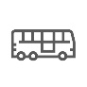
The Rilano Hotel Stuttgart-Böblingen
Phone: +49 (0) 7031 6450
E-Mail: reservierung-boeblingen@rilano.com
15 rooms reserved for the event from 12th – 14 th of June 2024
Double room: 105.00 EUR per night & room
Please use the booking code “CONNECT 2024” when booking your room.
This booking allocation is scheduled to end on the 28 th of May 2024

Arthotel ANA Living Böblingen

Fair Hotel

5 min

20 min

15 min
Otto-Lilienthal-Straße 18/1
71034 Böblingen - Germany
www.ana-hotels.com/living-stuttgart
Phone: +49 (0) 7031 677990
E-Mail: living-stuttgart@ana-hotels.com
15 standard rooms reserved from 12th – 14 th of June 2024
Double room: 119.00 EUR per night & room
Please use the booking code “CONNECT 2024” when booking your room.
This booking allocation is scheduled to end on the 28 th of May 2024

Hotel NH Stuttgart Sindelfingen

Fair Hotel

7 min

14 min

22 min
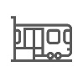
Riedmühlestraße 18-20
71063 Sindelfingen - Germany
https://www.nh-hotels.com/
Phone: +49 (0) 7031 6980
E-Mail: reservierungen@nh-hotels.com
100 double rooms reserved from 12th – 14 th of June 2024
Double room: 129.00 EUR per night & room
Please use the booking code “CONNECT 2024” when booking your room.
This booking allocation is expected to end on the 28 th of May 2024

Erikson Hotel

Fair Hotel

7 min

12 min

20 min
Hanns-Martin-Schleyer-Str. 8
71063 Sindelfingen - Germany
https://www.erikson.de/home-en.html
Phone: +49 (0) 7031 93 5 0
E-Mail: info@erikson.de
10 rooms reserved for the event from 12th – 14 th of June 2024
Standard room: 99.00 EUR per night & room
Please use the booking code “CONNECT 2024” when booking your room.
This booking allocation is scheduled to end on the 27 th of May 2024

Landhaus Feckl

Fair Hotel

10 min

24 min

35 min
Keltenweg 1
71139 Ehningen – Germany
https://www.landhausfeckl.de/en/
Phone: +4917034 2377 0
E-Mail: info@landhausfeckl.de
5 rooms reserved for the event from 12th – 14 th of June 2024
Standard room: 119.00 EUR per night & room
Please use the booking code “CONNECT 2024” when booking your room.
This booking allocation is scheduled to end on the 05 th of June 2024

V8 Hotel

Fair Hotel

< 1 min
Charles-Lindbergh-Platz 1
71034 Böblingen - Germany

V8 HOTEL Böblingen | Motorworld Region Stuttgart | V8 Hotel Stuttgart

Phone: +49 (0) 70313069880
E-Mail : info@v8hotel.de

Mercure Hotel Stuttgart Sindelfingen

Fair Hotel

8 min

30 min
Schwertstraße 65
71065 Sindelfingen – Germany
https://www.mercure-stuttgart-sindelfingen.de/en/
Phone: +49 (0) 7031 61960
E-Mail: info@mercuresindelfingen.com

Hotel Business Bay

Fair Hotel
6 min
Neckarstraße 46
71065 Sindelfingen- Germany
Phone: +49 (0) 172 4757419

V Business Apartments Böblingen

Fair Hotel

7 min

18 min

15 min
Stuttgarter Str. 69
71032 Böblingen - Germany
https://www.v-boutique-hotel.de/english-summary.html
Phone: +49 (0) 7031 / 92 999-80
Fax: +49 (0) 7031 / 92 999-88
E-Mail: mail@v-hotelgesellschaft.de

Hotel Stuttgart Sindelfingen City by Tulip Inn

Fair Hotel

7 min

13 min

15 min
Waldenbucher Str. 84
71065 Sindelfingen - Germany
https://tulip-inn-stuttgart-sindelfingen-city.goldentulip.com/en-us/
Phone : +49 (0) 7031 865 0
E-Mail : info@tulipinnstuttgartsindelfingencity.com

Centro Hotel Böblingen

Fair Hotel

3 min

14 min
Wolf-Hirth-Straße 8/1
71034 Böblingen - Germany
https://www.centro-hotels.de/de/standorte/stuttgart/Centro-Hotel-Boeblingen/centro-hotel-boeblingen.html
Phone: +49 (0) 7031 62030
E-Mail: reservierung@centro-hotels.de

Hotel Waldhorn Böblingen

Fair Hotel

10 min

18 min
Böblinger Straße 1
71034 Böblingen - Germany
https://hotel-waldhorn.de/
Phone: +49 (0) 7031 76720
E-Mail: info@hotel-waldhorn.de

BB City Hotel

Fair Hotel

7 min

15 min
Marktstraße 44
71032 Böblingen - Germany
https://www.city-hotel.com/en/
Phone: +49 (0) 7031 225087
E-Mail: post@city-hotel.com

Hotel Böhler

Fair Hotel

8 min

14 min
Postplatz 17
71032 Böblingen - Germany
https://www.hotel-boehler.com/en/
Phone: +49 (0) 7031 46040
E-Mail: mail@hotel-boehler.com

V Boutique Hotel Böblingen

Fair Hotel

7 min

17 min

16 min
Otto-Lilienthal-Straße 32
71034 Böblingen - Germany
https://www.v-boutique-hotel.de/english-summary.html
Phone: +49 (0) 7031 4662046
E-Mail: mail@v-boutique-hotel.de

the niu Star

Fair Hotel

6 min
Neckarstraße 38
71065 Sindelfingen- Germany
Hotel Sindelfingen the niu Star | City-Hotel Sindelfingen | the niu
Phone: +49 (0) 7031 2961940
E-Mail: reservation@novum-hospitality.com

Hotel Berlin

Fair Hotel

7 min

18 min

19 min
Berliner Platz 1
71065 Sindelfingen - Germany
https://www.hotelberlin-sindelfingen.de/en/
Phone : +49 (0) 7031 865 5
Fax : +49 (0) 7031 865 600
E-Mail : info@hotelberlin-sindelfingen.de

